SKILL-13
- To Parse Input Redirection, Open Files, Redirect stdin, Handle Missing Files, Restore Streams, Test File Inputs.
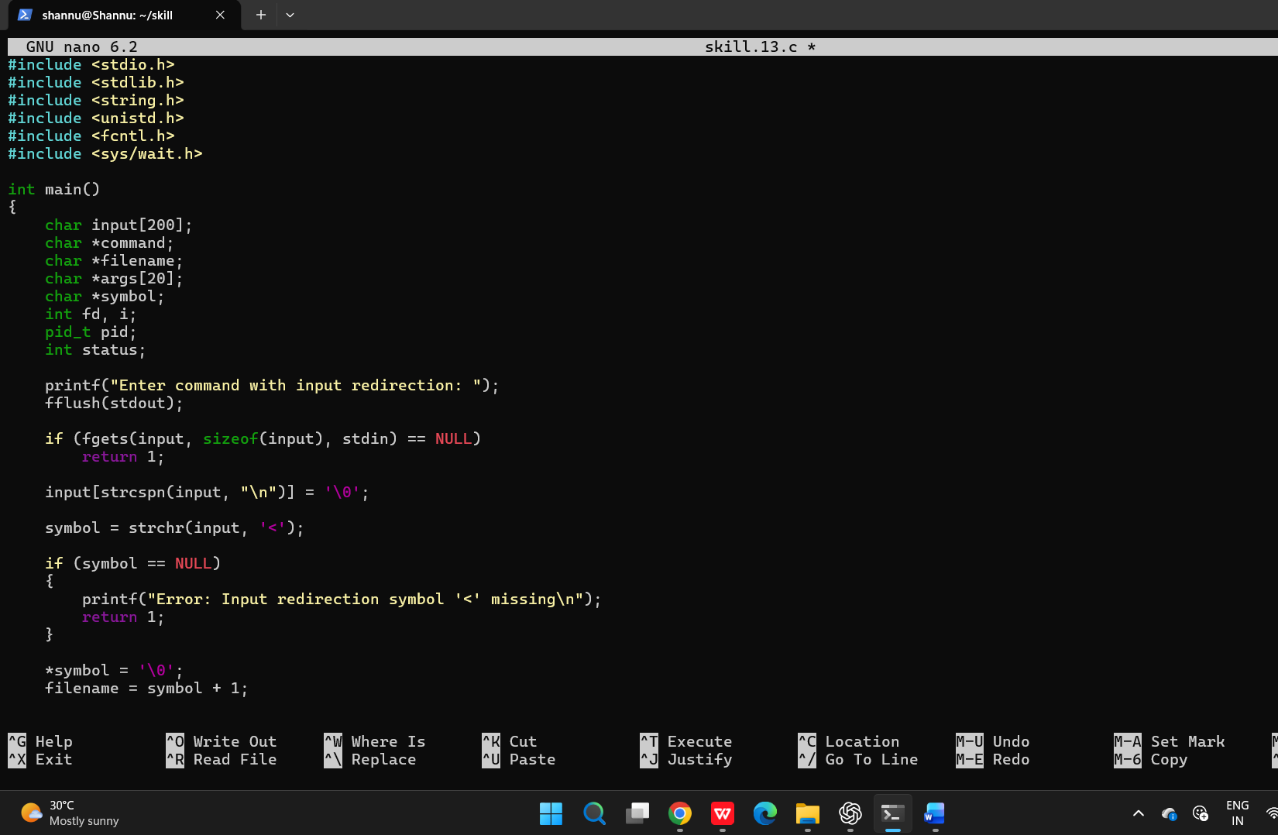
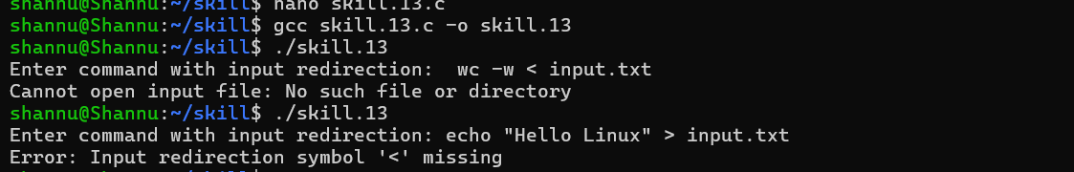

To Parse Output Redirection, Create Output Files, Redirect stdout, Handle Permissions, Verify Output Data, Test Redirection.
